Webelos Scout Uniform
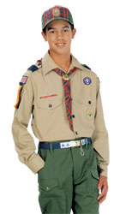

Webelos Scouts may choose to wear either the blue Webelos uniform based on the Cub Scout uniform or the tan/olive uniform similar to the one that Boy Scouts wear.
For the tan/olive uniform, boys wear the official Boy Scout olive trousers or shorts and official Boy Scout tan long- or short-sleeved shirt with blue shoulder loops. Official blue socks (with gold tops) are worn with the blue uniform, and official olive socks (with red tops) are worn with the tan/olive uniform.
With either uniform, all Webelos Scouts should wear the Webelos neckerchief (plaidwith the Webelos emblem), Webelos neckerchief slide (handmade slides are alsoacceptable), Webelos cap, and Weblos belt buckle.
Note that the Webelos belt buckle will only fit the blue cotton web belt (item number 64046-64048).

