Cub Scout Uniform
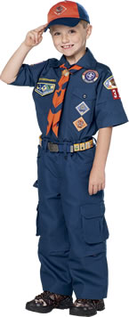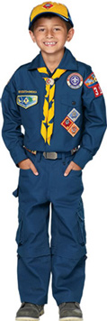

The Cub Scout uniform has the following parts:
- Shirt—The official uniform shirt is available with long or short sleeves and has button-flap pockets and "Boy Scouts of America" lettered in gold above the right pocket.
- Trousers or shorts—Official blue.
- Belt—Official navy-blue web belt with metal buckle and Tiger, Cub Scout, or Webelos Scout emblem.
- Socks—Official socks are available in three lengths: ankle, crew, and knee. Tigers' socks are navy blue with orange tops. Cub Scouts' socks are navy blue with gold tops.
- Cap—Official navy-blue cap with orange front panel and tiger cub emblem for Tigers; yellow panel and wolf emblem for Wolf Scouts; blue panel and bear emblem for Bear Scouts. Webelos Scouts wear an olive cap with a plain panel bearing the Webelos logo.
- Neckerchief—Triangular neckerchief is orange with navy-blue trim for Tigers, gold with navy-blue trim for Wolf Scouts, light blue with navy-blue trim for Bear Scouts, and plaid for Webelos Scouts. Official BSA neckerchiefs are the only neckerchiefs that boys should wear. Packs should not make their own pack neckerchiefs.
- Neckerchief slide—Official gold-tone metal slide with the Tiger, Cub Scout, or Webelos Scout logo. Boys may wear handmade neckerchief slides.

