CUB SCOUT PACK FLAG CEREMONY

OPENING

Caller: Attention. Will the audience please rise? (Pause.)
The color guard waits in the back of the room for the audience to stand and become quiet.

Caller: Color guard, advance.
The pack flag guards and bearer are on the left, and the U.S. flag guards and bearer are on the right. With the U.S. flag in the lead, they walk in and cross so that the U.S. flag will be on the left side of the room when you look toward the front. The bearers and guards take their positions near the flag stands, facing the audience and holding the flags vertically.

Caller: Hand salute.
Everyone, with the exception of the flag bearers and guards, salutes.

Caller: Please repeat with me the Pledge of Allegiance.
(All join in.)
The bearers and guards stand at attention and continue to hold the flags. The pack flag is lowered slightly so that the U.S. flag stands taller. The U.S. flag guards and bearer and pack flag guards and bearer do not salute or say the Pledge of Allegiance.

Caller: Two.
The pack drops its salute. The pack flag is raised to its vertical position again.

Caller: Color guard, post the colors.
The pack flag is placed in its stand. Its guards and bearer step back into place. The U.S. flag is then posted. Its guards and bearer salute it and step back into place.

Caller: Color guard, dismissed.
The U.S. flag guard leads the procession to the back of the room with the narrator following last.

Image of Opening Advance

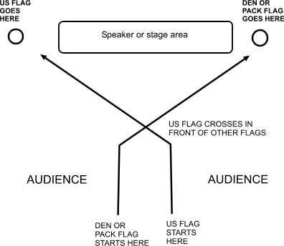
CLOSING

Caller: Will the audience please rise? (Pause.)
The color guard waits in the back of the room for the audience to rise and become quiet.

Caller: Color guard, advance.
The U.S. flag guard and bearer and pack flag guard and bearer walk down the aisle and to the flags. They stand behind the flags, facing the audience.

Caller: Color guard, prepare to retire the colors.
The guards and bearers salute.

Caller: Hand salute.
Everyone, with the exception of the flag bearers and guards, salutes.

Caller: Color guard, retire the colors.
The U.S. flag is removed first (just slightly ahead of the pack flag).

Caller: Hand salute.
Everyone, with the exception of the guards and bearers, salutes. The U.S. flag stays on its “marching right” as the guards and bearers proceed down the aisle to the rear of the room.

Caller: Two.
Everyone drops the salute.

